

**College of Science and Engineering**

**Faculty of Electronics and Communication Engineering**

**ECE583 Advanced Embedded Systems**

*(Fall 2022)*

**Course Project**

***IOT Smart Waste Management System***

**Submitted by**

|  |  |
| --- | --- |
| **Student Name** | **ID Number** |
| Habiba Hassan | 2018-11594 |
| Kareem Saad | 2018-04373 |
| Yasmin Amr | 2018-03452 |

**Submission Date**

06/01/2023

**Submitted To**

Assoc. Prof. Amr ElSayed

Eng. Malak Yousry

Eng. Samar Ayman

Table of Contents

Abstract 3

1. Introduction 4

2. Theoretical Background 5

3. Design Specifications 6

3.1. Design Description 6

3.2. Design Components 6

3.2.1. Hardware Components 6

3.2.2. Software Interface 6

3.3. Mathematical Model 6

4. Implementation and Design Verification 7

4.1. Procedures for Connecting the Components 7

4.2. Software Design 7

4.3. Project Results 7

5. Extra Features 8

6. Cost Analysis 8

7. Conclusion and Recommendation 9

8. References 9

List of Figures

Figure1: Design Flow Chart……………………………….…………………………………………..……2

# Abstract

Poor waste management techniques followed around the world, especially in developing countries, play a leading role in the global warming crisis we’re facing today. It has become an undeniable fact that this way, our dear earth is on the verge of facing a horrendous, irreversible disaster. Besides, the hideous sight of overflowing trash bins, the untidy streets, not to mention the costs of waste collecting cars that roam the streets everyday searching every bin for garbage to collect. These problems have been the motivation behind this project. A smart waste management network using IOT & ARM processors. Simple as this. IOT applications have been proven to be energy efficient, and as for ARM processors? They are the powerful microprocessors most used nowadays.

This report provides a detailed description of the whole process of the project design, block diagram, hardware implementation, and STM32 microcontroller code. Finally, it discusses the limitations faced during the operation, and the future work to avoid them.

# Introduction

By March 2018, 80 million tons of garbage is collected in Egypt each year. An estimated 55.2 percent household's solid waste is collected by private companies, while 44.8 percent of the households dispose their waste by dumping it onto the street.

Up to 40% of Egypt's generated waste is not operated by public or private institutions, but placed in streets, rivers, lakes, drainage channels or illegal dumping sites. Only an estimated 6% of the produced waste is collected, and only partly recycled.

This is a statistics from the Egyptian government:

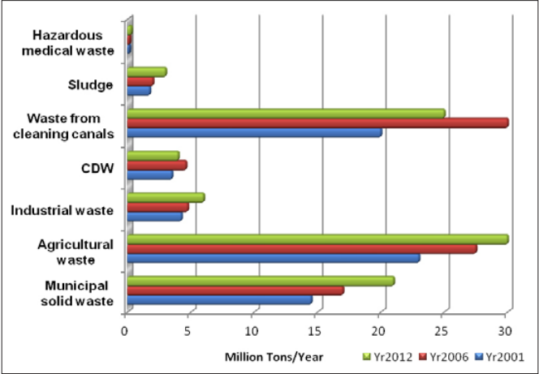

# Theoretical Background

The traditional way of manually monitoring the wastes in waste bins is a cumbersome process and utilizes more human effort, time and cost which can easily be avoided with our present technologies. The idea struck us when we observed that the garbage truck used to go around the town to collect solid waste twice a day. Although this system was thorough it was very inefficient, as some garbage cans may be full, and some are not. Our system provides an indicator on the IOT application and a LED when the garbage can reaches 80%. This alerts the waste management unit to pick up the trash. This helps save time and increase efficiency. The system also sends the trash level continuously. This will help the waste management unit to decide which area to pick the trash from first (for time efficiency). Additionally, the servo motor turns 90 degrees to close the garbage can, so no overflowing happens. The project targets waste management units. It will help save their time and increase their efficiency. Moreover, it will help keep a clean environment, by reducing waste pollution. The peripherals we will be using are UART, Timers, and Interrupts.

# Design Specifications

## Design Description

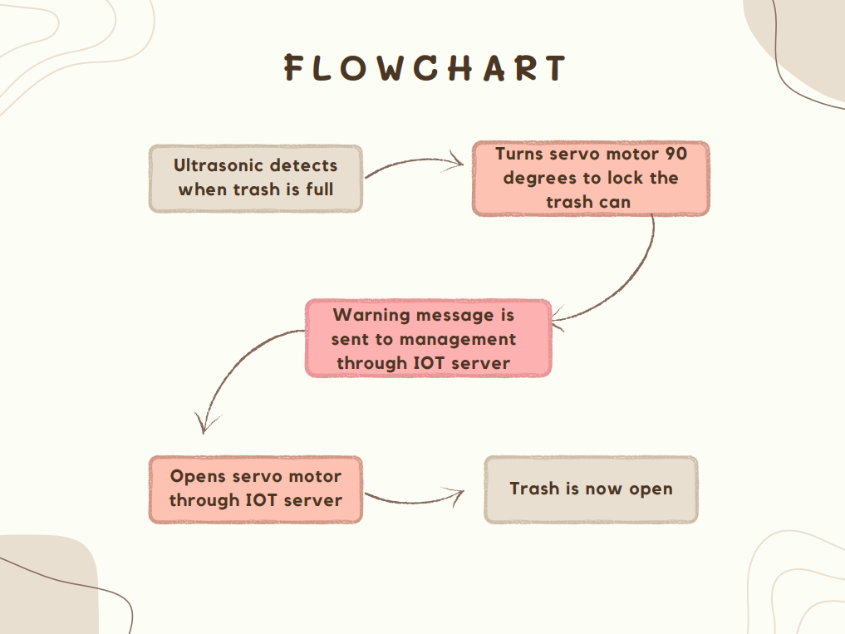

## Design Components

### Hardware Components

The Black Pill (ARM-CortexM4) is a system on chip powerful micro-controller that have many functionalities and used to make DIY Projects, The Bluetooth module is used as a prototype to our IOT application, Servo Motor is used to lock our can when the wastes in the can reaches a certain percentage, Red Led is used with the servo in order to deliver a message for the passenger that this can Is not available for use in the current time, Ultra Sonic sensor is used in order to sense the wastes and deliver a signal to the servo motor to lock the can.

Ultrasonic Sensor

STM32F401

Bluetooth Module

IR Sensor

SPI

Servo Motor

IOT

Application

LED

### Software Interface

1) STM32 Cube Programmer, Amazing tool that requires the configuration of the clock, timers …etc. used then it generates the needed code for the project

2) Bluetooth electronics, Android Mobile app that is used to interface with the micro-controller to perform the required task

## Mathematical Model

* **Servo Motor:**

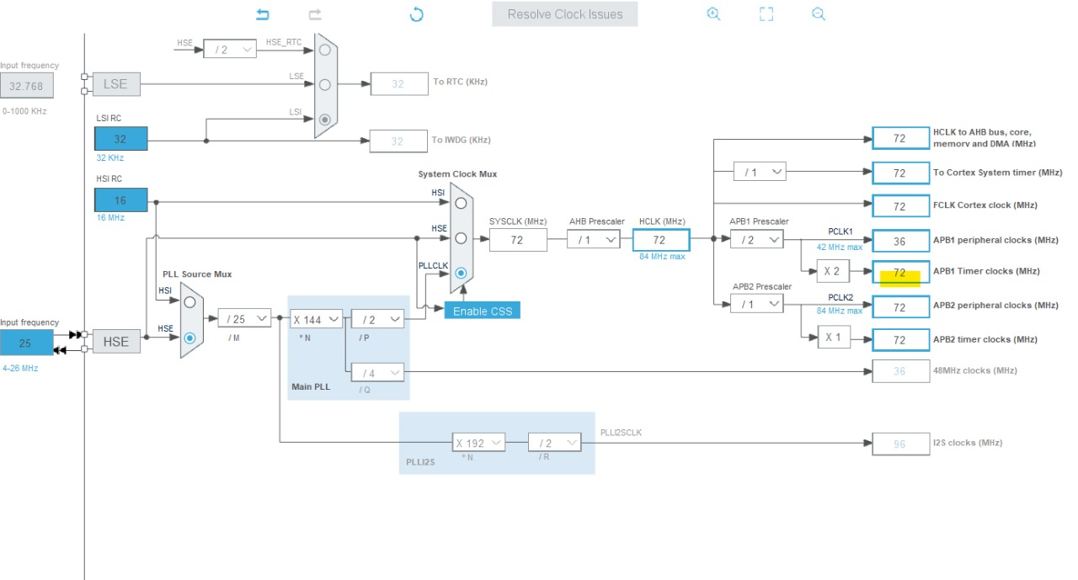

* The Servo Motor needs 50 Hz. The APB1 Timer clock = 72 MHz & Our prescaler = 72. Upon dividing 72M by 72 we get 1MHz. Divide this again by 10,000 to get 100 Hz. 100 Hz is the period of the signal (10ms). Controlling the Ton time of the signal varies the rotation direction of the servo motor. This is shown in the figure below. Setting the 0 degrees value by setting the PWM width as 750. 1,000,000/750=1333.33 Hz. The time is 1/1333.33= 0.75 ms. (which is approximately 1ms, it is not exact as our pulse width is 10ms not 20ms). Increasing the value of the PWM width to 1650 will set the servo to 90 degrees. 1,000,000/1650=606.06. 1/606.06= 1.65ms.

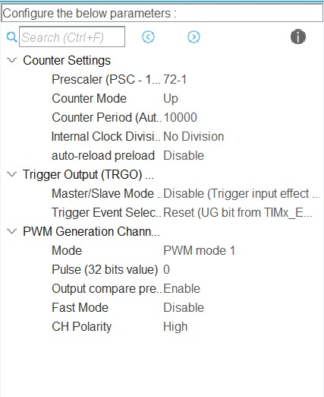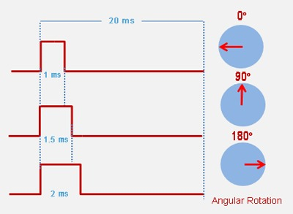

* **Ultrasonic Sensor:**

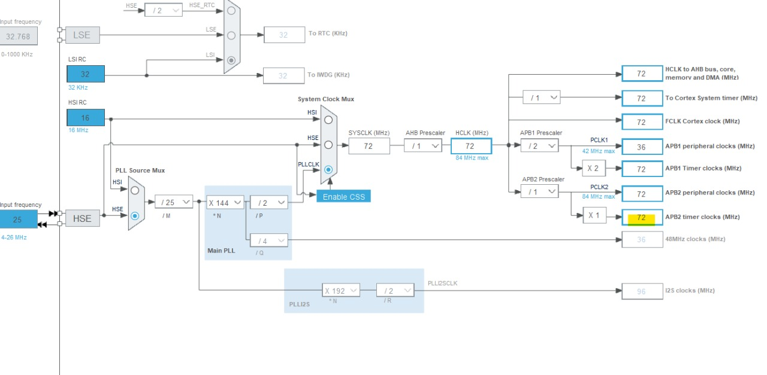

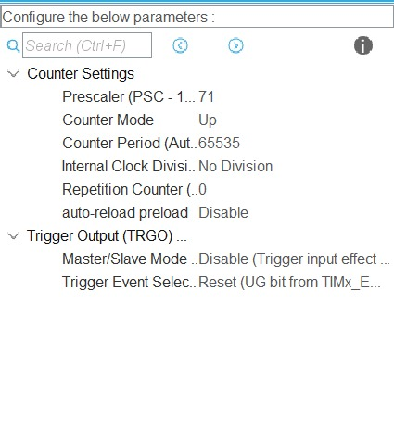

Prescalar is set to 72 -> This will divide the APB clock by 72, and bring the timer clock to 1 MHz. It is necessary because the HCSR04 sends the signal in microseconds.

# Implementation and Design Verification

## Procedures for Connecting the Components

* Starting with the Ultrasonic sensor, 1st pin is the VCC which is 5V then the echo pin connected to PinA8 (Timer channel 2) and the trigger pin connected to PinA9 (Which is output) and finally the last pin is the ground pin.
* Then with the Servo motor, first pin is the VCC (5V), Second pin is the control pin which is connected to Pin A1 then the last pin is the ground pin.
* The LED’s two pins, one is connected with the PinA0 and the other one is connected to the ground.
* The Bluetooth module, Rx is connected to PinB6, Tx is connected to PinB7, the third one is connected to the ground and the last one is connected to the ground.

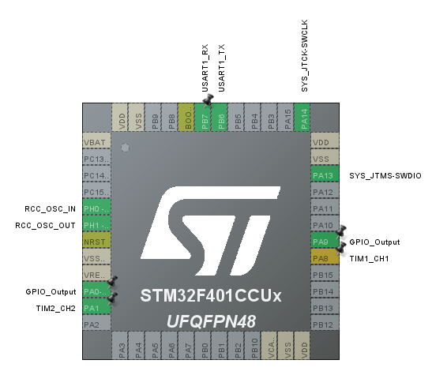

## Software Design

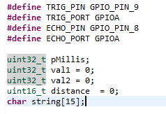

* Trigger is set as an output to trigger the ultrasonic sound pulses. (PIN9)
* Echo is set as a timer to produce a pulse when the reflected signal is received. This allows us to count the time it took for the wave to be received. (PIN8-Timer1)
* Val1 indicates the initiation time of the transmitted signal
* Val2 indicates the time in which the ultrasonic receives the signal.
* Distance measures the distance that the wave travelled.

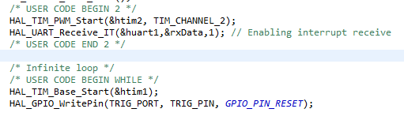

* The first line activates the PWM wave for the servo motor that operates on Timer2.
* The 2nd line enables the interrupt when the Bluetooth module receives a signal.
* The 3rd line enables timer 1.
* The 4th line: pMillis is a variable used to store the elapsed time in milliseconds.

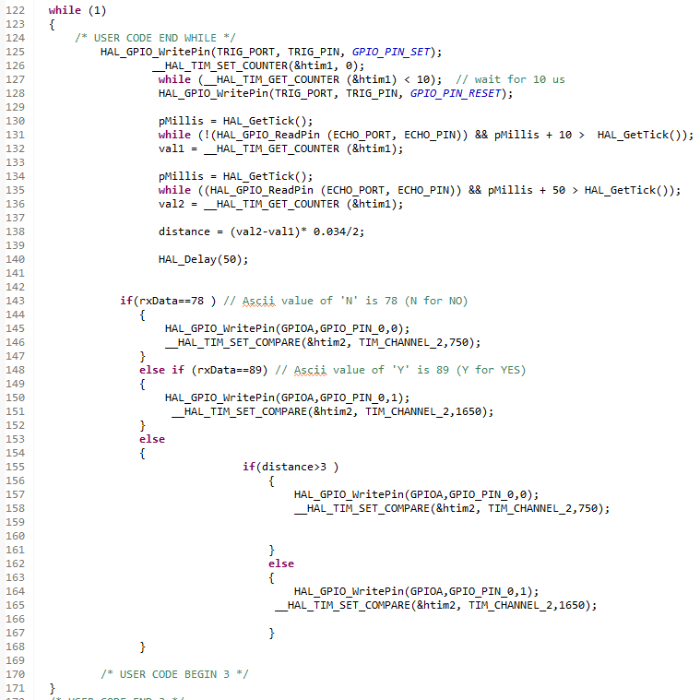

Line 126: Setting timer to zero

Line 127: Setting the trigger pin to HIGH for 10µs, the sensor initiates an ultrasonic burst.

Line 131-136: The echo pin goes high when the ultrasonic burst is transmitted. When it goes high, we save the time in the parameter val1. The pin will remain high until the sensor receives an echo, then it goes low, which is when we save the time in val2.

Line 138: Calculate distance (cm) =speed (cm)*time

Line 143-168: The ASCII code of N is 78, which resembles the button on the IOT server is off, meaning the servo is closed (0 degrees). The ASCII code of Y is 89, which resembles the button on the IOT server is on, meaning the servo is open (90 degrees). Considering our prototype: a can with 12.5 cm height, the servo will lock when it reaches 80% of the full can, which is nearly 3cm (0 degrees), else it will stay open. (90 degrees)

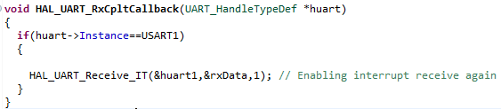

This interrupt service routine fires when the Bluetooth module receives a signal from the IOT application. (Bluetooth Electronics)

## Project Results

* Servo Actuator before Detecting Wastes:

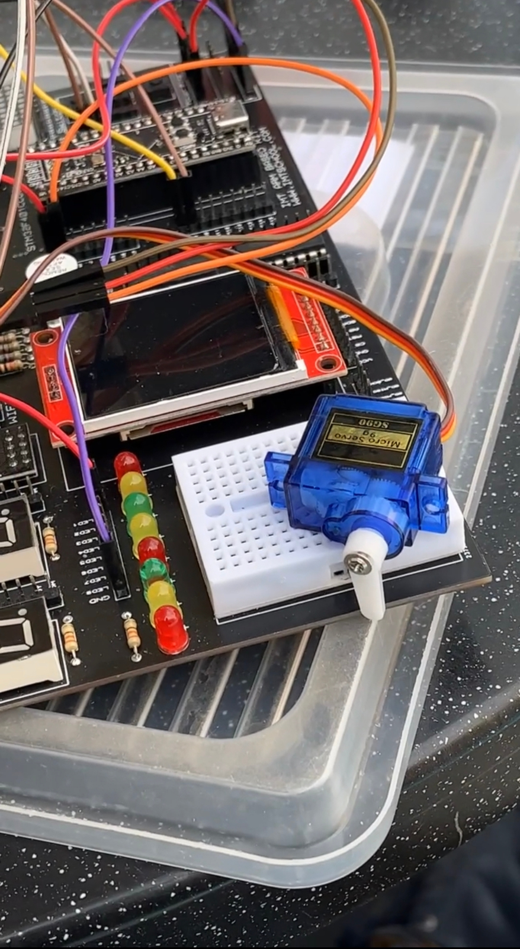

* Servo Actuator after Detecting Wastes

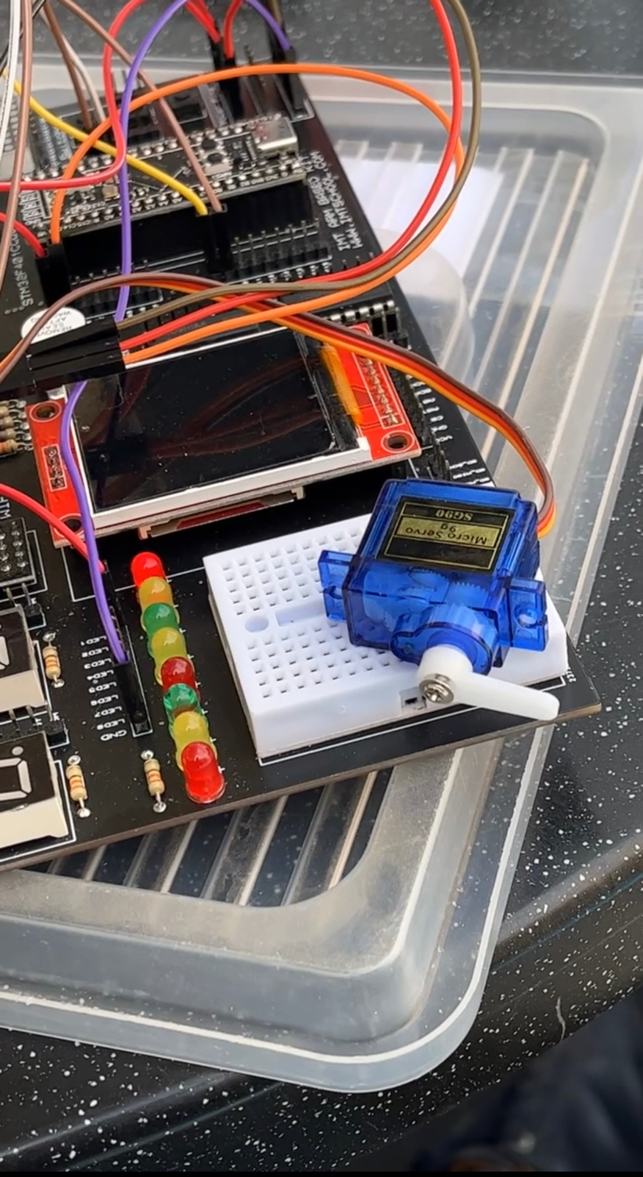

* Before Clicking on Button to Interface with Bluetooth

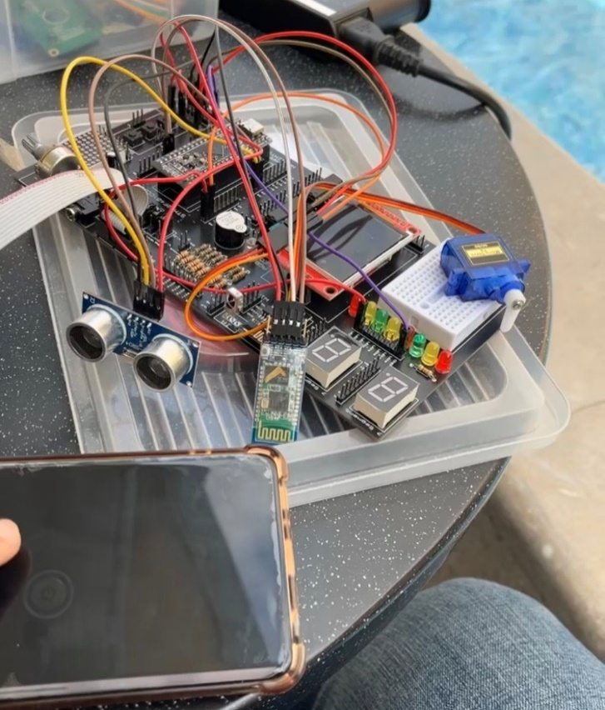

* 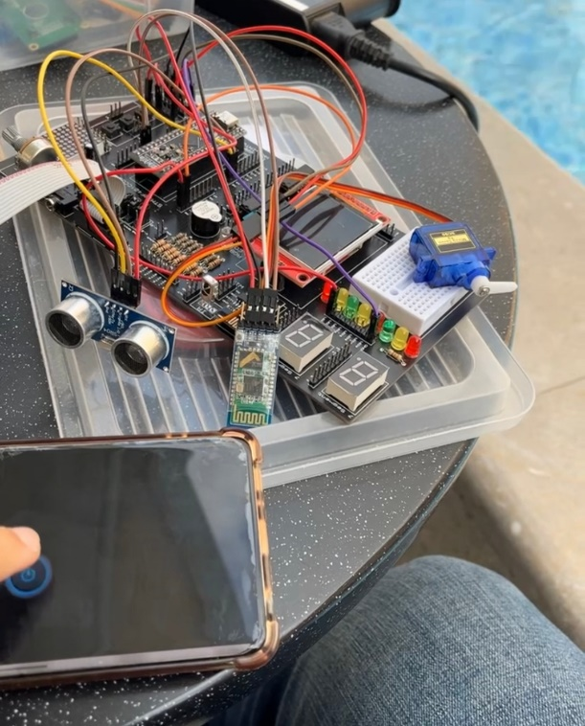After Clicking on Button to Interface with Bluetooth

# 

# Extra Features

• An IR sensor to be integrated into the system in order to detect human presence so that the trash can lid can open & close automatically without the need to touch the lid.

• A PIR motion sensor for safety precautions to prevent the lid from closing on a person’s hand or trapping an animal inside.

•To extend the IOT services so it provides the garbage level in every garbage can & sends it to the waste management unit. The unit can then decide which can needs to be emptied without the need for cars roaming the streets every day.

• The system can also detect how many days the trash has been there in the can to avoid rotting and bad odors. It can signal to the management unit if 2 days or so have passed so it can send a car to collect.

# Cost Analysis

**STM32F401** 320 L.E

**LED**

5 L.E

**Ultrasonic Sensor**

65 L.E

**Bluetooth HC05**

220 L.E

**Servo Motor**

70 L.E

# Conclusion and Recommendation

To conclude, this project is just a prototype with limited features that needs further modifications in the future in order to add the extra features mentioned previously. It also needs more testing and to finish the incomplete test scenarios. The idea is just a step towards building a huge functional waste management network for a clean, energy & time efficient society. It also suits as a start up, but needs more fund.

# References

1. <https://www.handsontec.com/dataspecs/HC-SR04-Ultrasonic.pdf>
2. <https://www.instructables.com/Smart-Garbage-Monitoring-System-Using-Internet-of-/>
3. <https://controllerstech.com/hcsr04-ultrasonic-sensor-and-stm32/>
4. <https://www.youtube.com/watch?v=29yBoqdj-Gw>
5. [www.wmra.gov.eg/en-us/ReportsandGuidelines/ReportsandIndicators/Documents/2013_Annual Report for SWM in Egypt_EN.pdf](http://www.wmra.gov.eg/en-us/ReportsandGuidelines/ReportsandIndicators/Documents/2013_Annual%20Report%20for%20SWM%20in%20Egypt_EN.pdf)